1. Install IIS  
   Ensure Internet Information Services (IIS) is installed on your Windows server.

* Open ‘Windows Features’ on the PC you wish to install the server on and tick ‘Internet Information Services’. This will install IIS on your computer. A restart may be required.   
   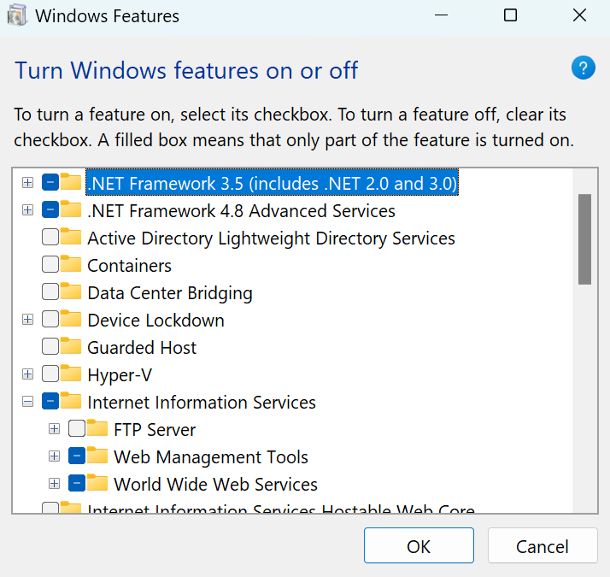

1. Install URL Rewrite ModulE
   * Download and install the URL Rewrite Module from Microsoft's official website (<https://www.iis.net/downloads/microsoft/url-rewrite>)
   * Restart IIS after installation.
2. Install Application Request Routing
   * Download and install Application Request Routing (ARR) from Microsoft's official website (<https://www.iis.net/downloads/microsoft/application-request-routing>)
   * During installation, make sure to enable the proxy feature.
   * Restart IIS after installation.
   * You can enable it by clicking on the main server, then double clicking on   
     Then enabling Proxy as follows, then Apply settings.  
     A screenshot of a computer

     Description automatically generated
3. Configure SSL Certificate

To obtain an SSL certificate for your domain:

* + In IIS Manager, select your server name in the Connections pane.
  + Double-click on "Server Certificates".
  + In the Actions pane, click "Import..." if you have a certificate file or "Create Self-Signed Certificate” to generate a new one. The name does not matter. Make the certificate store ‘Web Hosting’
  + Follow the prompts to install your certificate.

1. Create a New Website or Use an Existing One
   * In IIS Manager, right-click on "Sites" to add a new website or select an existing one.
   * Add your name to the site, example dev.finchposserver.com.au
   * Add the physical path, this can be anywhere
   * Set the binding type to HTTPS and select your SSL certificate.
   * Add the host name, match it to site name if possible.
   * Make sure the port you select here is different to the one used by iCaaS (I’m using 9888 for IIS and 9180 for iCaaS)
   * Make sure you are using the non HTTP version of iCaaS
   * Ensure the port entered here is open in the firewall/router AND that the one used by iCaaS is NOT.
   * For example (iCaaS internal is 9180, the port given for this IIS server is 9888)  
     A screenshot of a computer

     Description automatically generated
2. Configure URL Rewrite Rules
   * Open your website in IIS Manager.
   * Double-click on "URL Rewrite".
   * Click "Add Rule(s)..." in the Actions pane.
   * Select "Reverse Proxy".
   * Enter the internal URL of your web service (e.g., [**http://internal-service/**](http://internal-service/)).  
     A screenshot of a computer

     Description automatically generated
   * Enable "SSL offloading" if needed.
   * Click "OK" to create the rule.
   * Modify the rule to change the local port for iCaaS if required:  
     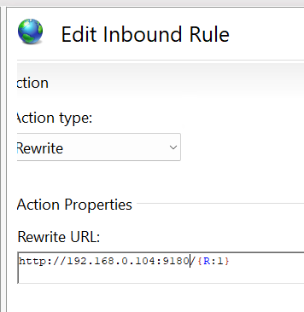
3. Adjust ARR Settings (Optional)
   * Open your server settings in IIS Manager.
   * Double-click on "Application Request Routing Cache".
   * In the right pane, under Proxy, adjust settings as necessary (timeout settings, etc.).
4. Test the Configuration
   * Add a firewall rule for the IIS port above, incoming.  
     A screenshot of a computer

     Description automatically generated
   * Access your web service externally using the HTTPS URL.
   * Ensure that requests are being routed correctly and that the SSL certificate is working as expected.